**PROJECT REPORT**

**COMPUTER NETWORKS  
SMART OFFICE** 

**SUBMITTED TO:**

SIR SHOAIB RAZA

**SUBMITTED BY:**

AISHA ANWAR 19K-1086  
FIZZA ZAKIR 19K-1106

**ABSTRACT:** In the era of technological development today, technology has become the need for the life of today's society. One is needed to create a smart office by turning on and off electronic devices via smartphone. So far, turning off and turning the office electronic device is done by pressing the switch or remote button, so in control of electronic device control is less effective. The office smart design is done by simulation concept by testing system, network configuration, and wireless office gateway computer network equipment required by a smart office network on cisco packet tracer using Internet Thing (IoT) control. In testing the IoT office network wireless network gateway system, multiple electronic devices can be controlled and monitored via smartphone based on predefined configuration conditions. The Smart office can potentially increase energy efficiency, decrease energy usage costs, control electronics and change the role of residents.

**INTRODUCTION:**

In the era of technological development today, without realizing the technology has become a need that is often used for the life of today's society. Where almost all areas have been able to feel from the development of such technology, as in the field of computer networks. In this case, the need for office technology is increasingly required to make a smart office, where during this time the control of electronic devices at the office is done through the on or off switch. Smart office is an application of a combination of technology and services devoted to the office environment with specific functions aimed at improving the safety, efficiency, and comfort of its inhabitants. In the smart office system usually consists of monitoring tools, control devices and automatic there are several devices that can be accessed using a computer or smartphone connected to the Internet network The Internet of Things is a system of interrelated computing devices, mechanical and digital machines, objects, animals or people that are provided with unique identifiers and the ability to transfer data over a network without requiring human-to-human or human-to-computer interaction. In the Internet of Things, all the things that are being connected to the internet can be put into three categories: - Things that collect information and then send it - Things that receive information and then act on it - Things that do both

**METHODOLOGY:**

In this study apply literature and experimental study methods, which in the literature study obtained from Internet media in the form of journals, e-books and material books. While experimentally done using software and hardware that is designed for its performance and done testing to make the application, whether it is as expected. In the configuration and testing of network systems by designing the concept of smart office IoT model which then tests each subsystem model, in the end after subsystem testing, testing the overall system model to see the success. level model of smart office systems designed on cisco packet trackers. It uses the IoT office gateway as the media path that connects multiple wireless devices wirelessly and provides automatic addressing to devices connected to the office gateway, where all devices connect to the smartphone as an interface medium for controlling and monitoring electronic devices.

**Features:**

1. **RFID Based Door Lock:** Door can be unlocked only by using a valid RFID card. If anyone wants to enter the office, he or she has to show RFID. If the RFID is valid, the door will be opened, otherwise not.
2. **Smart Window, based on light and rain:** Smart Window which will be opened automatically when it’s morning time and there is no rain using rain sensor, photo sensor. If it’s night the window will be closed to avoid the mosquitoes even if there is rain.
3. **Solar Power battery charging:** Based on solar power, the fan and light will be running automatically. But, if the battery power finishes, they won’t be running. The battery only charges itself when there is sufficient light.
4. **Anti-theft protection:** To provide anti-theft protection a trip sensor is being used, if anyone breaks the window and enters the trip sensor will give a siren as alert.
5. **Auto fan & coffee maker:** When anyone enters the canteen, the fan and coffee maker turns on itself detecting the motion.
6. **Music player:** Music can be played using a music player via Bluetooth on a portable speaker. Entertainment purpose.
7. **Smart street lamp:** Turns on when it’s night using a photo sensor. Energy saving.
8. **Smart garage:** Opens itself when detects smoke, means the car is turned on. Either it will be entering or going out. Garage door closes itself when there is no smoke, meaning either the car is far or it’s turned off inside the garage.
9. **Fire alarm & smoke alarm:** If anything catches fire, the fire detector will give a siren to alert everyone. If a ridiculous amount of smoke is generated by a vehicle, the smoke detector will siren alert.

**Used Devices:**

**IOT devices:** Fan, light, Window, Garage, Door, Battery, Siren, Solar panel, Appliance, Portable music player, Motion Detector, Street lamp, Old car, Fire monitor, RFID card, RFID reader, Trip sensor, Fire sprinkler, Smoke detector.

**Sensors:** Custom made rain sensor, Photo sensor, Smoke sensor.

**Actuators:** Led, speaker, alarm.  
  
**Requirements:**

* Cisco packet tracer pc application version 7.2.1.

**COMPLETE VIEW IN CISCO:**

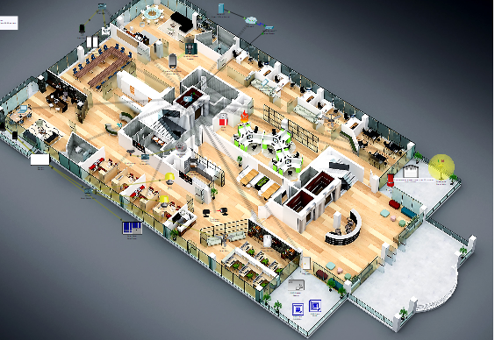

**IOT DEVICES OFFICE CONTROLLER:**

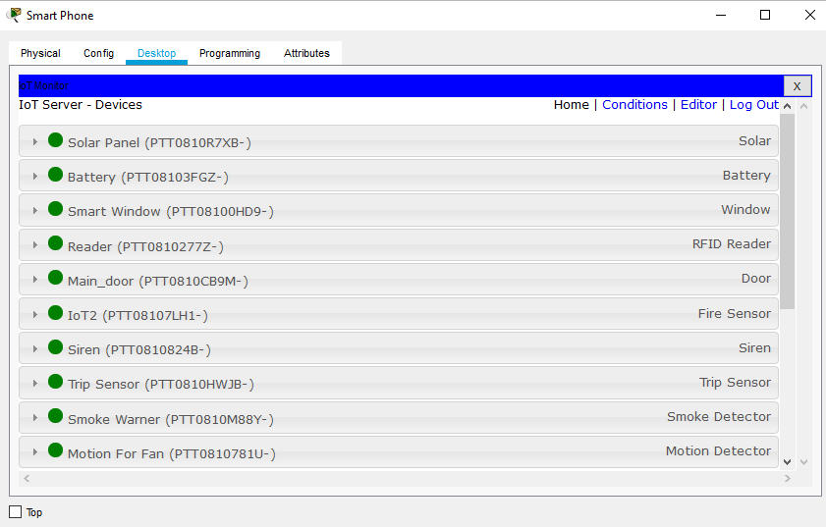

**DHCP POOL FOR IOT DEVICES:**

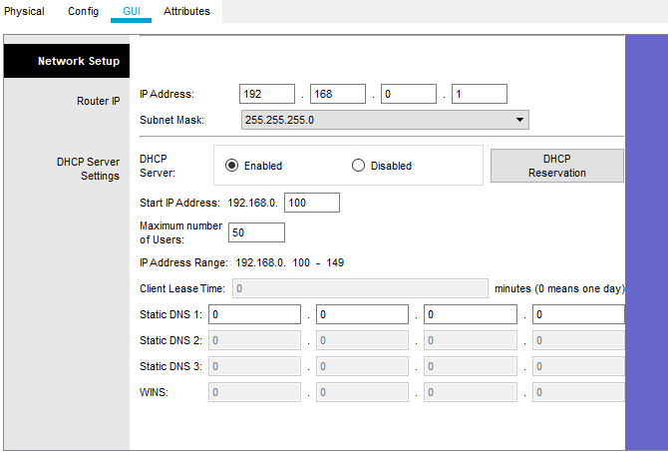

**INTERNET SERVER:**

